# **How to Bring Database Online from Emergency Mode in SQL Server**

The database is essential for every user since it preserves all of an organization's vital information. It is highly susceptible to numerous issues due to the vast amount of data it contains. There are a number of situations where the SQL Server database becomes inaccessible and is flagged as Suspected. Additionally, until a database is backed up, a user is not permitted to view it or take any actions on it while it is in emergency mode.

The processes for fixing a faulty SQL database and returning from emergency mode to normal mode will be covered in this article.

## **What does SQL Server's Emergency Mode mean?**

Let's first define emergency mode before understanding how to recover the database from it. When the database's transaction logs are damaged and there isn't a recent backup, the emergency mode is essentially employed. The standard repair command will not function in this circumstance. The reason for this is that when the transaction logs are damaged, repairs are totally logged and cannot be used. Additionally, users have access to the database even while it is in emergency mode. Additionally, the ability to access the suspicious database and restore it from emergency status is granted with Read-Only permission.

## **Why do Users Restore Databases in Emergency Mode?**

There are numerous reasons why the SQL database enters suspicious status. However, some of them are more frequent than others. Therefore, we explore several common causes for the SQL server issue before you bring the database online from the suspect mode in the SQL server.

* **Database Corruption:** If your SQL database is flagged as questionable, it may become corrupt.
* **Malicious Attacks:** The SQL server database entering suspect mode is also a result of any malware attack.
* **Hardware Issues:** This issue may potentially be related to any hardware issues.
* **Log File Corruption:** Every SQL database has a transaction log that keeps track of all transactions and database changes. The SQL database could become corrupt for any number of reasons, including a faulty transaction log file.
* **Improper System Shutdown:** This is the most frequent cause of corruption problems. Therefore, it is advised to prevent erroneous system shutdowns.

## **How Can SQL Database Be Recovered From Emergency Mode To Normal Mode?**

Follow the procedures listed below to learn how to recover a database using emergency mode:

1. **Verify the suspected status of a SQL database**

Verifying if the database is in the suspected state is the first step. Run the command listed below to access the database's data and do the same action. However, the command will produce an error message if the database is questionable.

SELECT name, state_desc FROM sys.databases WHERE name = Test_Database

2. **In emergency mode, move the SQL Server database**

Simply activate the database's emergency mode by running the following command after you are certain that SQL is in suspect mode:

ALTER DATABASE databasename1 SET EMERGENCY

3. **To repair SQL Server, use DBCC CHECKDB**

You can begin the procedure to restore the database from emergency mode as soon as the emergency mode is activated. But by removing all incompatibilities that are the cause of the suspected mode, this repair command will assist. Now, a user must switch the database to single-user mode in order to perform the same action.

**Note**: Some data loss may occur throughout this process.

ALTER DATABASE databasename1 SET SINGLE_USER WITH ROLLBACK IMMEDIATE

GO

DBCC CHECKDB(databasename1,REPAIR_ALLOW_DATA_LOSS)

GO

4. **Enable Multi-User Database Access**

Simply turn on multi-user access to the database after the successful completion of the repair operation by using the following command:

ALTER DATABASE databasename1 SET MULTI_USER

5. **Online the Database**

To recover the database and return it to online mode, you must finally run the following command.

ALTER DATABASE databasename1 SET ONLINE

## **A Different Way to Recover Database from Emergency to Normal Mode**

Try looking for the most recent backup to restore the database and retrieve its data if your database is locked in EMERGENCY mode. Use SQL Database Repair software like [Stellar Repair for MS SQL](https://www.stellarinfo.com/sql-recovery.php) to restore your database to its original condition if the backup is damaged or not available.

The most recent SQL Server 2019, 2017, 2016, and other versions are all compatible with this SQL Database Repair software. Before storing your data, you can preview it to be sure you're recovering the correct information. The software can recover deleted records from the MDF file as well as lost data that you believed was permanently lost. In a single scan, it is capable of recovering several database objects, including tables, views, triggers, keys, rules, and more. The recovered data can be saved in a variety of file types, including CSV, XLS, HTML, and SQL scripts. Even non-technical individuals may easily utilize the software thanks to its user-friendly interface. Additionally, it includes a sophisticated scanning engine that can easily recover data from damaged MDF files.

Now, let’s have a look at the steps to use Stellar Repair for MS SQL,

1. Discover or search for the corrupted SQL database MDF file. 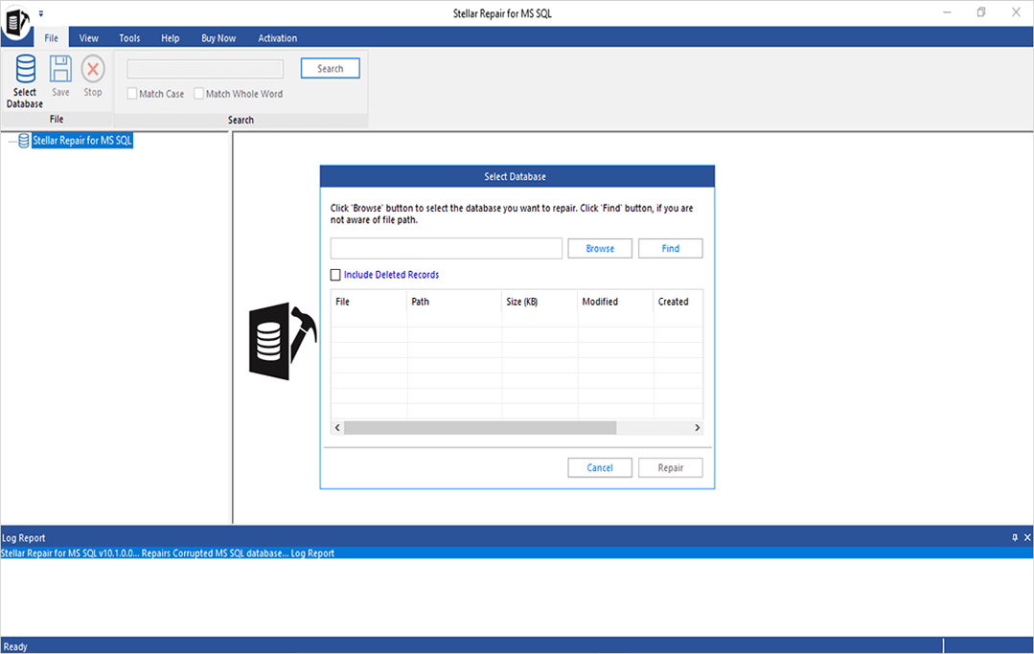
2. After selecting the SQL database MDF file, select Repair from the menu. 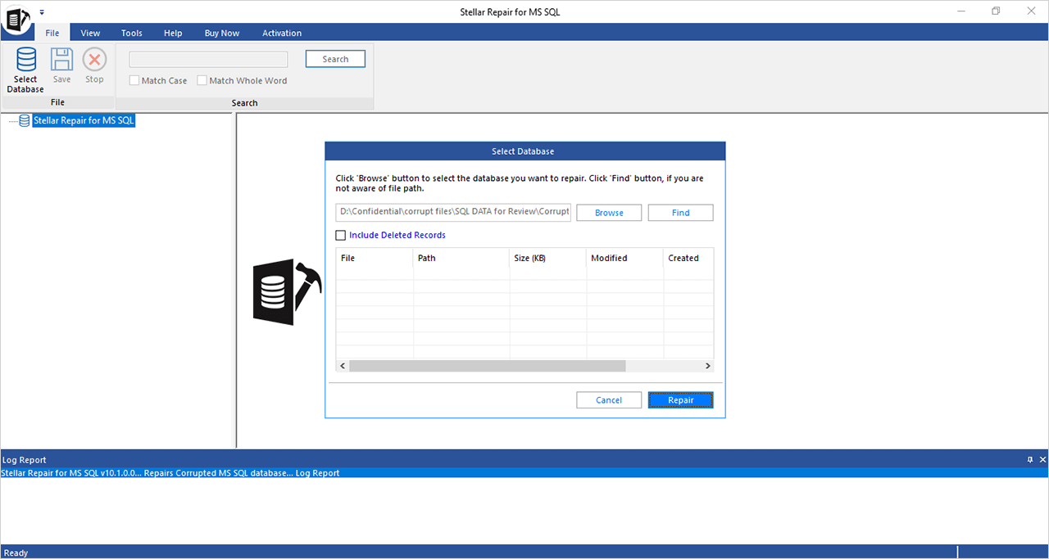
3. Choose a suitable scan mode, and click the OK button to correct the file. 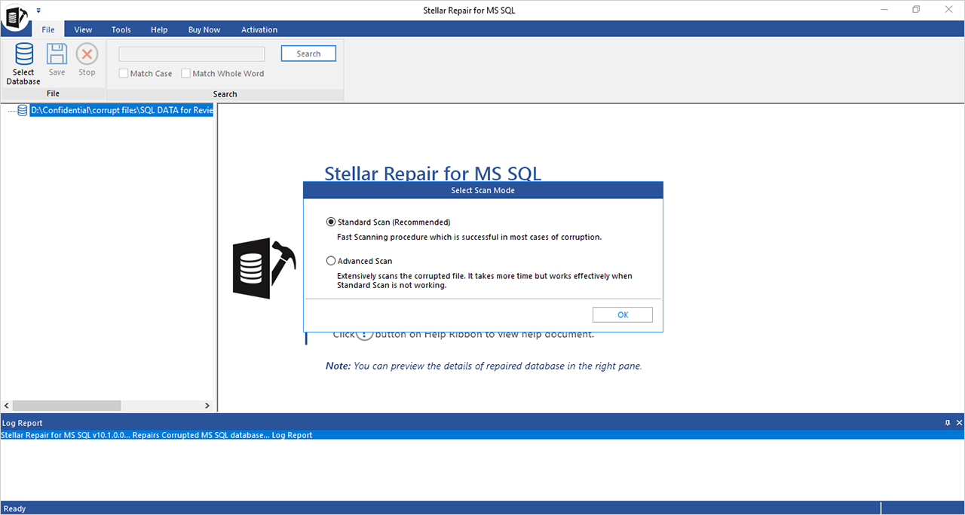
4. The program displays the status of the database file repair operation. 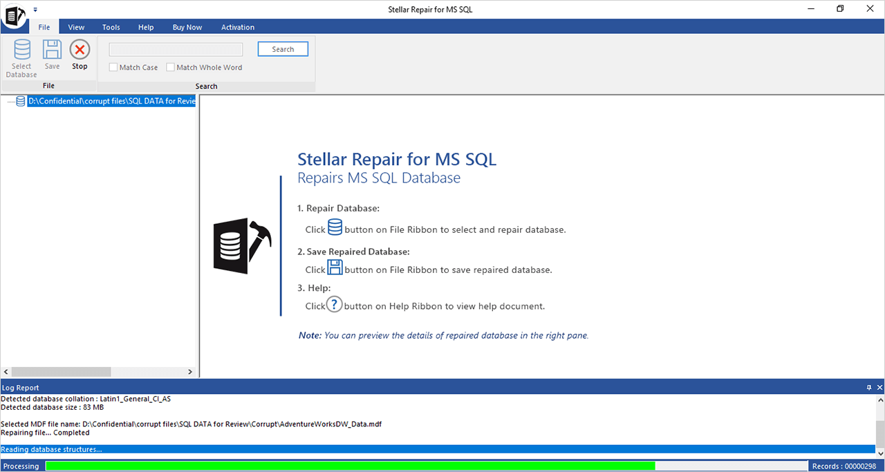
5. Click OK once the MDF file repair procedure has been successful. 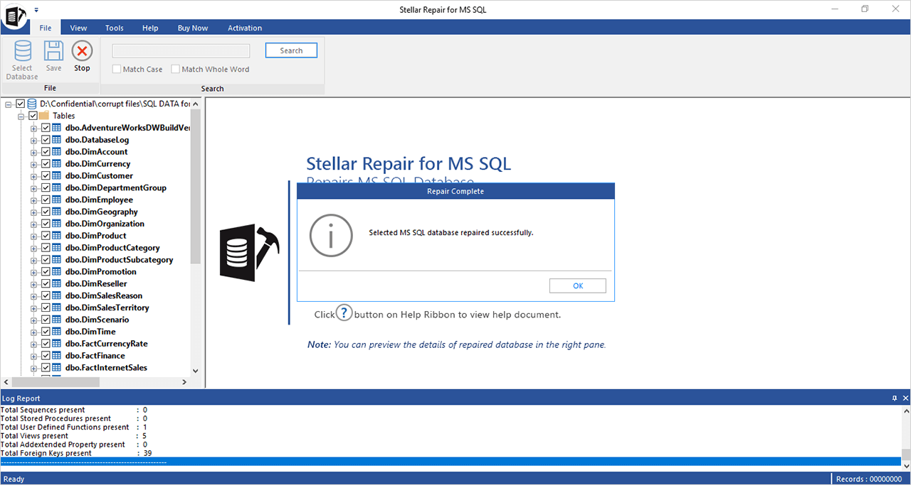
6. By choosing the Save option from the File menu, you can preview the recoverable database items and then save them. 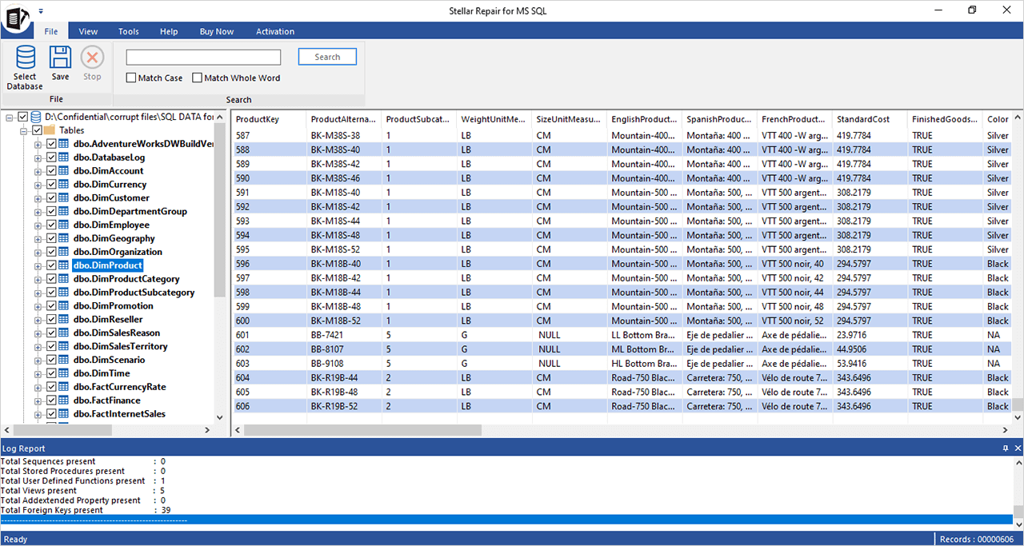
7. Choose the option to save the updated SQL database file, and then click the Next button to continue. 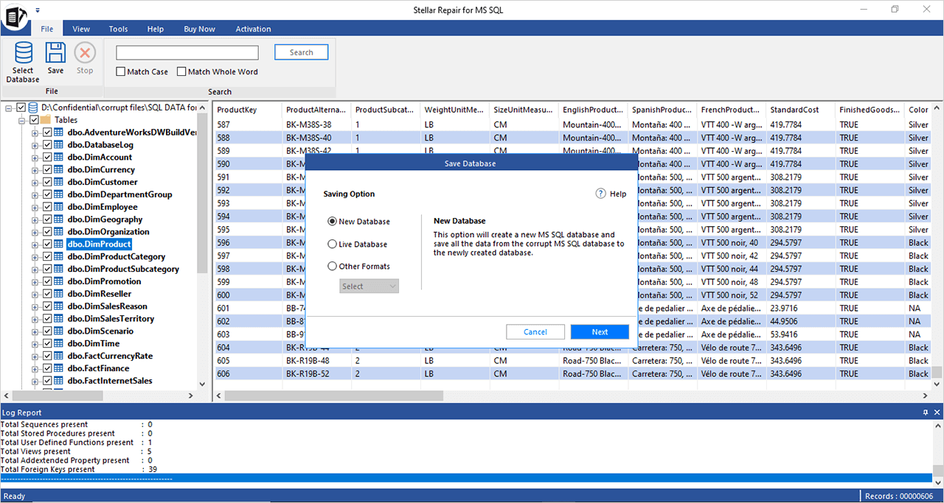
8. Click the Next button after entering the information required to connect to the SQL Server and save the corrected MDF file. 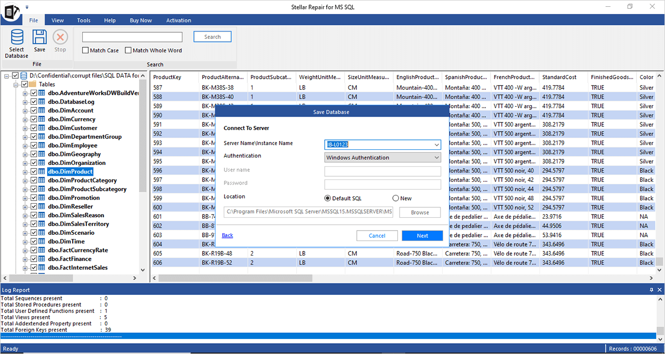
9. Select a suitable file-saving method, then click the Save button to continue. 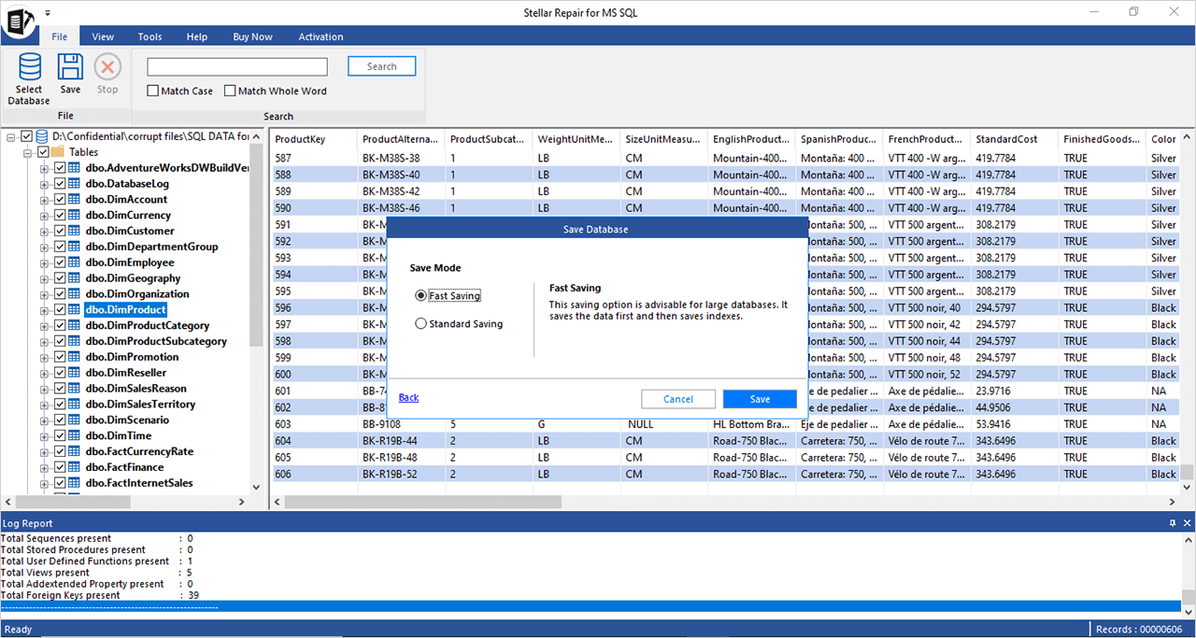
10. The program provides status updates for the file-saving process, including Finished, Processing, Pending, and Aborted. 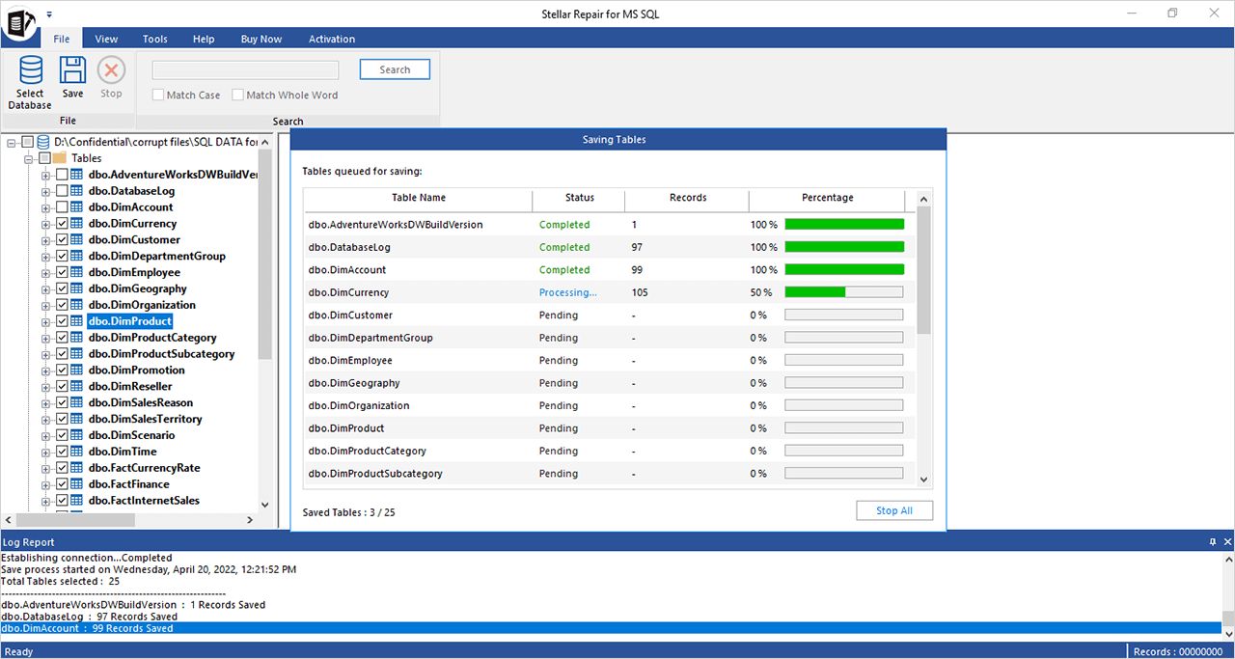
11. A confirmation message appears following the successful completion of the saving process. 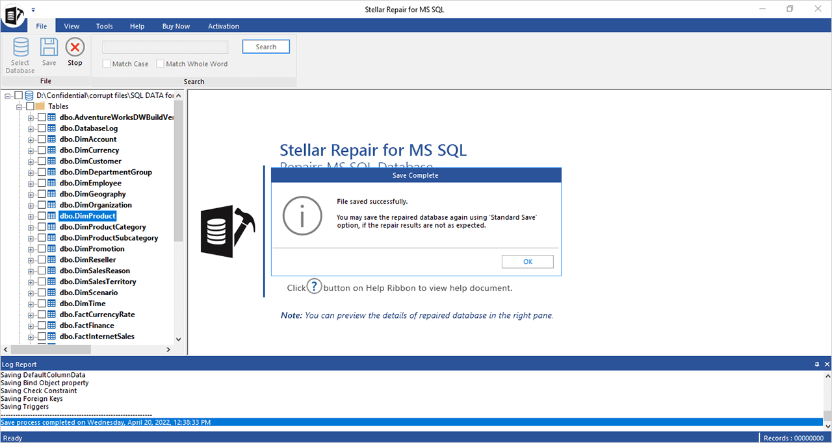

## **Conclusion**

We have covered how to recover a SQL Server database from an emergency mode in this post. Additionally, we now understand what Emergency Mode is, why SQL Databases are in Suspect Mode, and how using Emergency Mode in SQL Server enables us to access Suspect Databases.

To recover the SQL database from emergency mode, users can use the manual technique provided here. The issue, however, is that this approach does not work well with massive databases. Select [Stellar Repair for MS SQL](https://www.stellarinfo.com/sql-recovery.php) as the tool of choice if you want an assured method to recover a SQL database in emergency mode. This application is the best way to restore a database under SQL Server's emergency mode.